**LIMKOKWING MESSAGE APPLICATION FOR “TEACHERS”**

**INTRODUCTION**

We were required to create a simple an innovative application using Android studio. Our goal was to create an app that is easy to display some information about your teacher (picture, faculty’s department, position, phone number, email), to make a call and to send the message to them through LIMKOKWING application.

**METHODOLOGY:**

**Theme:**

Our app uses a color black as a custom theme.

**Navigation**

For navigation we used view-pager swipe-able view with tabs.

**For open** the app you must click on the "menu" for the main activity of LIMKOKING application. I circle it with the white color. Or you can download LIMKOKWING “for TEACHERS”

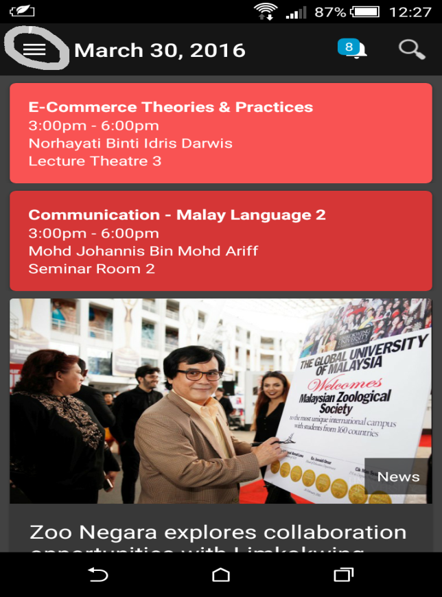

The logo of our application

LIMKOKWING for “Teachers”



**The Menu** is the new activity that contents the view of our app “**LIMKOKWING for** **Teacher**”, I circle it in white (1). By using the **LIMKOKWING for “ Teachers”** application,the activity is the welcome, it ask you to login your student Id and your password (if it is your first login) ( 2).

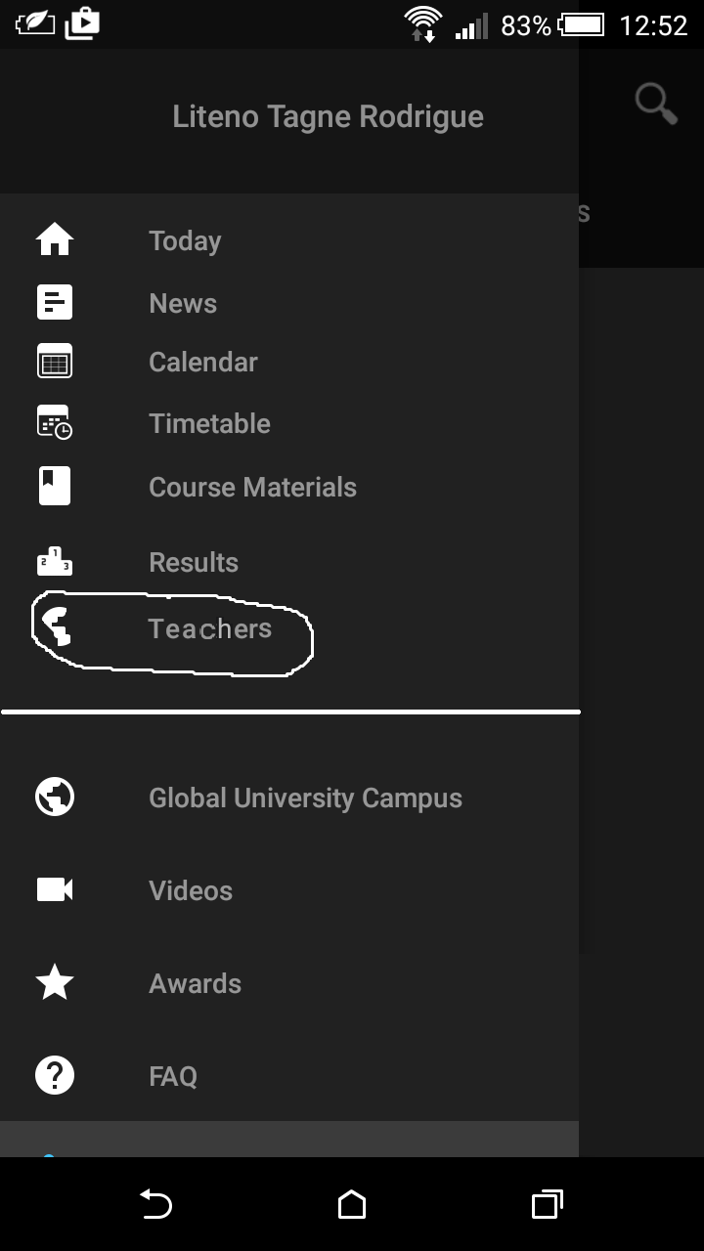

1

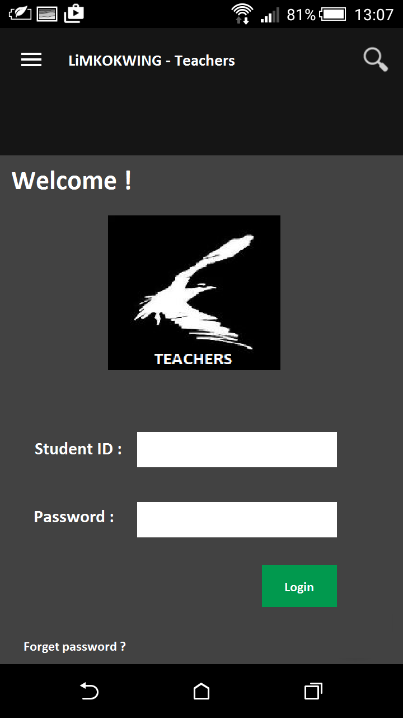

2

**The main activity of our app “Teacher”**

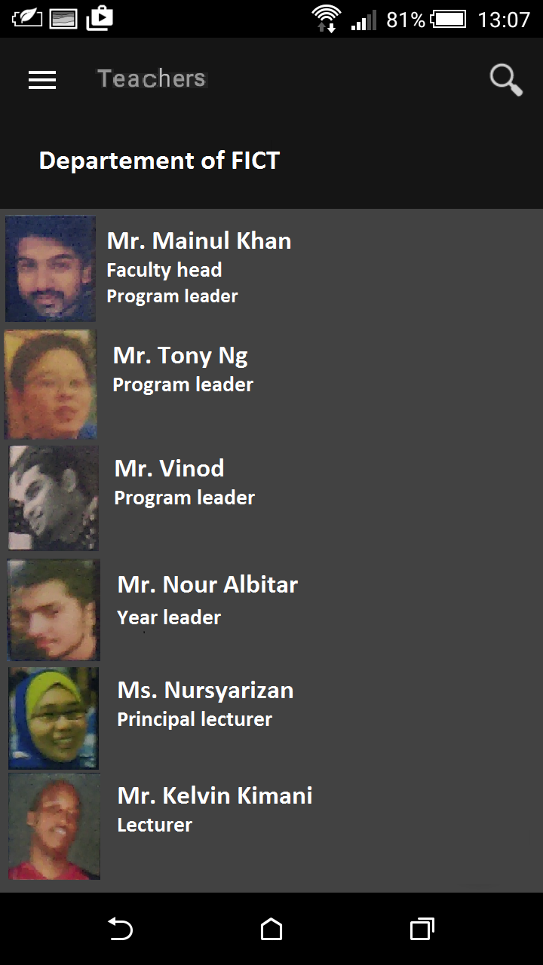

**Our app** is designing the action bar, we used a style inherited action bar widget style that come from LIMKOKWING application.

For the action bar design we used a custom style that inherited from the action bar widget style of the themes. Our tabs were customized the same way by inheriting from the native tab design and adding custom background, indicator and text appearance using color and xml for drawing. The Tabs hosted fragments.

* **The Home Fragment** which displayed the department’s members of the faculty information communication technology (department of FICT). (green arrow)
* **The research bar** (red arrow)
* **The contacts view** of the department’s members of the faculty information communication technology which had an expandable view grouping articles into categories: The picture, the logo of phone number and the message. (orange arrow)
* **The notification bar** usuallygets time, level of the battery, the level of network and some notification. (blue arrow)
* **The down stair’s bar** gets 3 events that already definite android system.(pink arrow)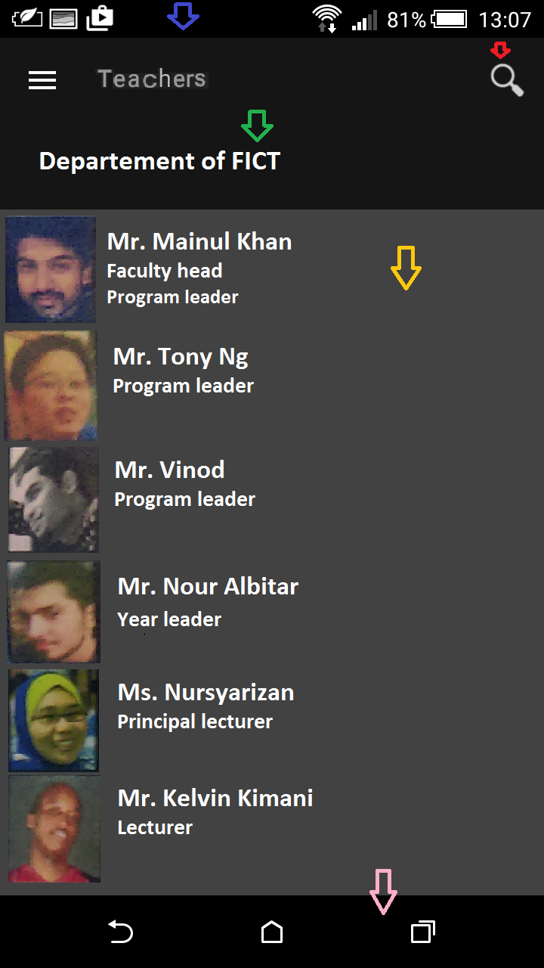

**The action**

**Our app** helps students of the university who have access to their portal (Id and password) of communicate, exchange messages and get some information directly their teachers using the LIMKOKWING’s application.

**The event** is to touch the view contact professor with whom you want to communicate that then opens a new activity. It displays the name of the professor, the photo of the professor, a logo for a message, a logo for the call, a logo for more information.

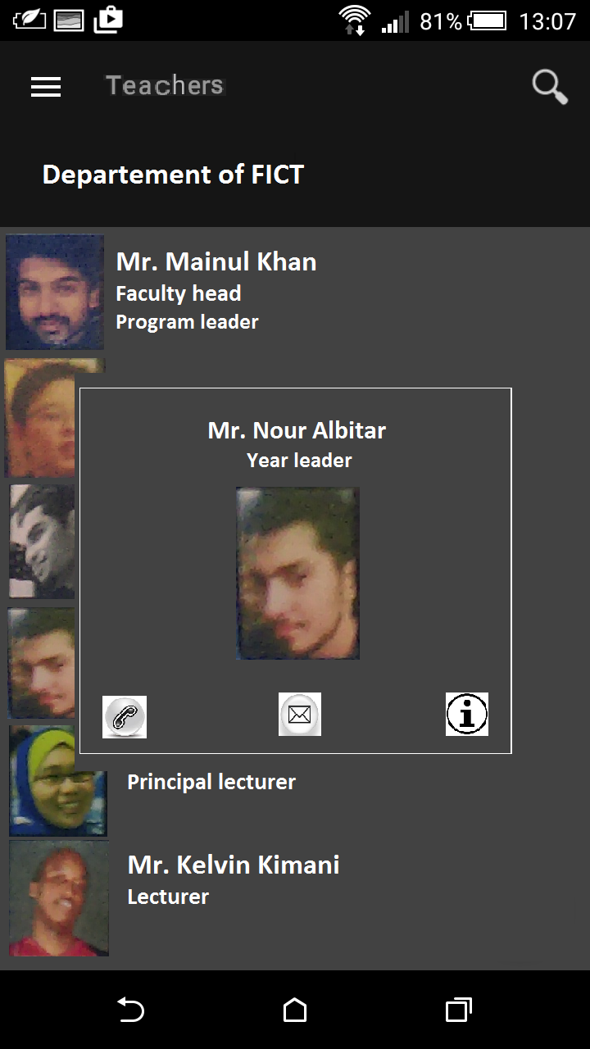

**The new activity**

The event opens the new activity of our app, which displays the information of the contact view we choose. These 3 new activities are call, send message and information.

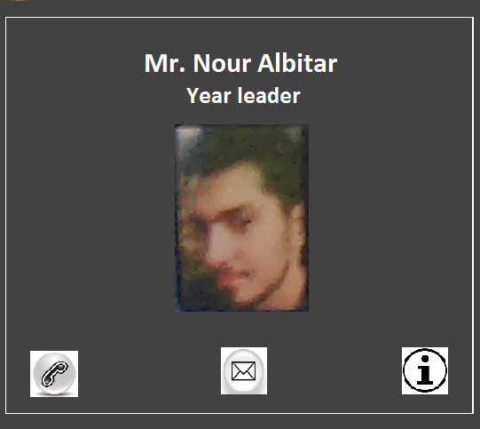

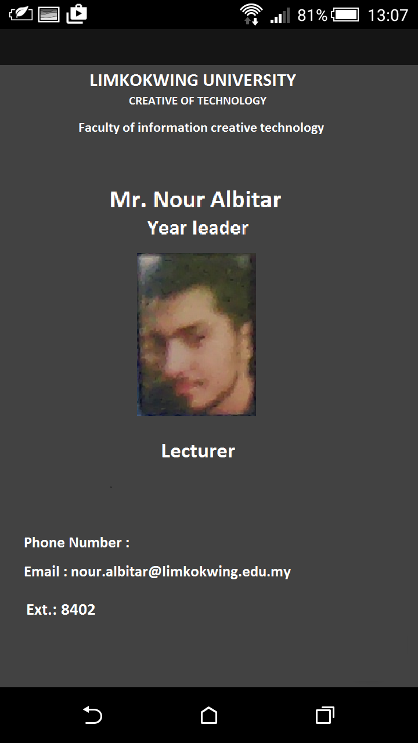

**Database**

**Storage**

We used a few kinds of storage;

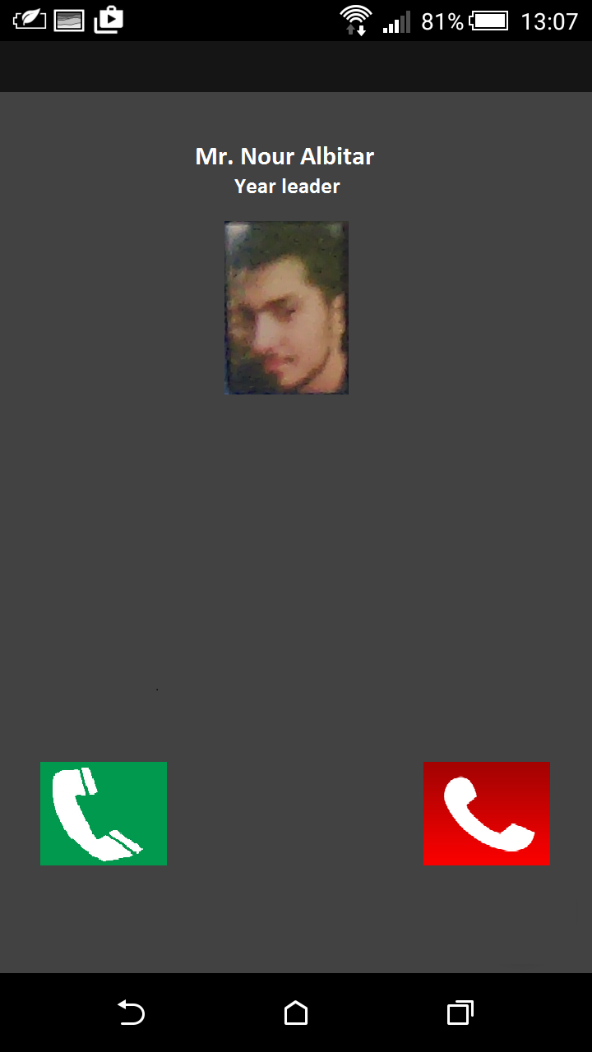

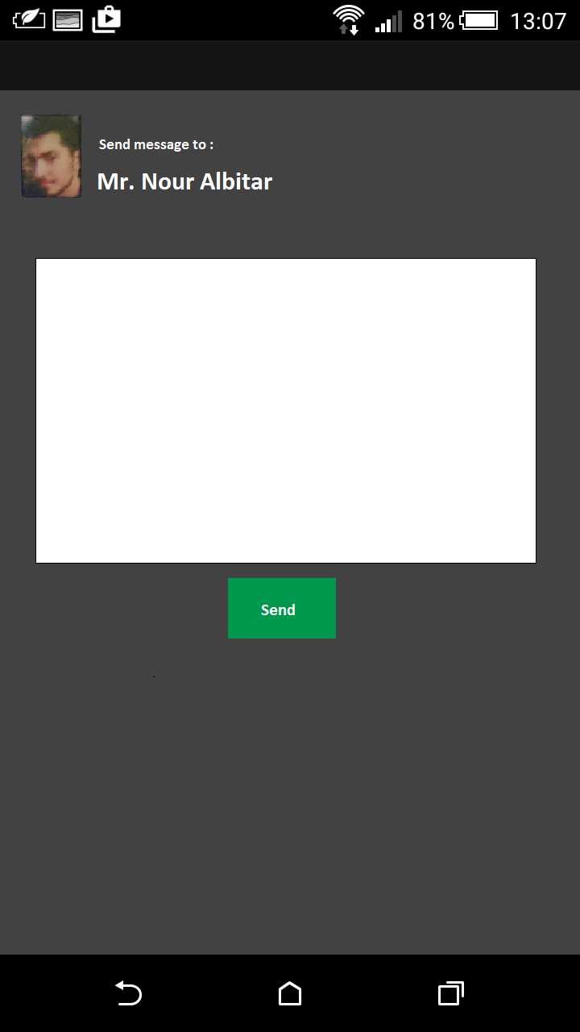

Finally we stored our data, messages, communications and information in the database of the LIMKOKWING application. We used a simple database application with a table with four fields.

* ID
* Password
* Information
* And the picture
* etc.

We got the information and link it to a custom list view fitted with an XML layout file.

**Problems and solutions**

A few of the problems we faced included;

* Not easy to use Android App Studio n because we had no experiences but with practice and with the teacher, it may be possible to install this application.
* The use of Android Studio is different because we have to use XML for design and JAVA for the functionality of our application. With a good knowledge of programming it can be easy to use.
* It is not obvious use all the features of android studio because our laptop application are not powerful enough, with a more powerful computer, everything would be easy.
* The updates of our application depends those of LIMKOKWING because it contains implementing our database.
* When your phone is connected to the network, you directly receive notifications of messages and calls that you r receipts, if your portal is closed you do not get any. Our application uses only the data that teachers have recorded. So if you have not added to the phone number user can call the teacher.

**Conclusion**

The project was a learning experience that we started without much knowledge of Java, XML, and the objective of the Android APIs are now more confident in Java and Android at least. The Android API is still large library so that we -Have more to learn. Our hope is a program that further facilitates communication and exchanges between our teachers and we had the time.

**References:**

https://github.com/rodliten/rod

https://guides.github.com/activities/hello-world/?utm_source=onboarding-series&utm_medium=email&utm_content=hello-world-link&utm_campaign=welcome-email

https://www.github.com

https://www.google.com

https://www.limkokwing.net/

https://www.youtube.com

Power Point: software to modify picture

The link of my github: